website manual

online hats shopping

Algonquin college

Abeer, Ayoub, Hans

Welcome to our website! As you embark on exploring our platform, you'll discover a specialized hub dedicated to offering a diverse range of hats from renowned brands like Adidas, Nike, and Under Armour. With an inventory of 15 to 20 carefully curated items, our home page serves as the central showcase. The constant presence of a header and footer provides a seamless and user-friendly experience throughout your journey. Join us as we delve into a detailed exploration of all the options available, guiding you to make the most of your time here.

the website will have a header with five options: home page, control panel, my cart, login, and sign up. On the home page, all products will be displayed with detailed information, including an "add to cart" option. Users can utilize the filtering and searching bars for a more tailored experience. The consistent footer will feature the copyright information for the year 2023. We'll make sure to cover each option and provide users with a comprehensive guide on navigating and using the website effectively.

# Home Page:

On the home page, users can find the products with the search bar. Just type in a brand like in the example below “Puma" or start a search with a letter, and you'll see matching hats. Use the filters to narrow it down by brand. Product details include an image, name, description, and price. When you spot the perfect hat, hit the green "add to cart" button.

# Control panel:

In the control panel, users have a comprehensive table with product details, including ID, name, description, price, and image. They hold the power to view, edit, or delete items with dedicated buttons, putting control at their fingertips. The "create new item" feature empowers users to seamlessly add fresh entries. This level of privilege is designed to enhance user control and provide a seamless, professional experience. It ensures users can tailor and manage their product listings efficiently.

## **Create new items:**

When users click "Create New Item" in the Control Panel, they're taken to a dedicated page. It starts with a bold "Create New Item" header. Below, they input item details: name, description, price, and upload an image. Once filled, they hit the "Create" button to add it to the database. For convenience, there's a "Back to List" option at the top to navigate back to the Control Panel. This ensures a straightforward process for users to seamlessly create and manage items.

**Delete Items:**

In the Control Panel, users can delete items by clicking "DELETE" next to the chosen item. This leads them to a confirmation page titled "DELETE ITEM." It asks, "Are you sure you want to delete this item?" with the specific item name mentioned (e.g., Nike). Users decide and can confirm by clicking "DELETE ITEM." A "Back to List" option is available for navigation. Consistency is maintained with the same footer and header across all pages for a seamless user experience.

**Edit items:**

Clicking "Edit Items" in the Control Panel directs users to a dedicated page. Here, they can edit the item's name, description, price, and image. The process includes choosing a file for the image and hitting the "Edit Item" button. Changes made will reflect on the home page when refreshed. A "Back to List" option, along with the consistent header and footer.

**View items:**

For "View Item" in the Control Panel, users can simply view item details without the ability to modify. Clicking "View Item" leads to a straightforward page displaying existing information like name, description, price, and image. No editing or changes can be made in this view-only mode. As always, the "Back to List" option and consistent header/footer.

# **My cart:**

On the home page, users can add items to their cart by clicking the green "add to cart" bar. This action directs them to the "My Cart" page. Here, the shopping cart title is displayed, showcasing all added items with details like product ID, name, description, price, and images. Users can adjust quantities and easily remove items with the green "remove" bar. Once satisfied, they can proceed to payment with the "Pay" option. The "Back to List" option and consistent header/footer maintain a cohesive user experience. A screenshot of a computer

When the user's cart is empty, the "My Cart" page displays a shopping cart icon with a message stating, "Your cart is now empty." They have the option to go "Back to Products" for further browsing. Additionally, a prompt encourages them to "Please log in or sign up to complete your purchase." This ensures a streamlined process for users to log in or sign up before proceeding with payment.

And this is how my cart look like when the user is logged in or signed up.

After users log in or sign up, when they proceed to pay, they'll see a summary of their shopping cart with the total amount. Upon clicking to enter payment information, they complete the process. Once done, the page confirms: "Your cart is empty. Back to Products. Thank you, your order has been successfully placed." This ensures a clear and reassuring message after a successful payment.

# Sign up:

To sign up, users click on the "Signup" option in the header. They're prompted to enter their username, email address, password, and retype the password. All fields are required for successful sign-up. Once completed, users can click "Signup." After signing up, the "Login" option in the header transforms into welcome, and the user's username for a personalized touch. This ensures users provide necessary information for a successful sign-up process. A screenshot of a computer

Sign up validation:

During sign-up, users need to be cautious with their input. If the username is already taken, an error message in red will inform them, saying "Username is already taken." If the email address is missing or invalid, another error message appears, stating "Please enter a valid email address" in red. Additionally, if the password and retype password do not match, an error message will display, saying "Password must match." This ensures users input accurate and unique information during sign-up.

After successfully sign up:

# Log in:

For login, users need to enter their username and password, which should match the information provided during sign-up. After inputting the correct credentials, they click the "Log In" button. Upon successful login, the page displays a welcome message, such as "Welcome Rail." This ensures a secure and straightforward login process for users.

log in validation:

If a user enters incorrect information during login, such as a wrong password, the system will display an error message, like "Invalid password." This prompts users to re-enter the correct information for a successful login attempt. This adds an extra layer of security and ensures users can rectify mistakes easily.

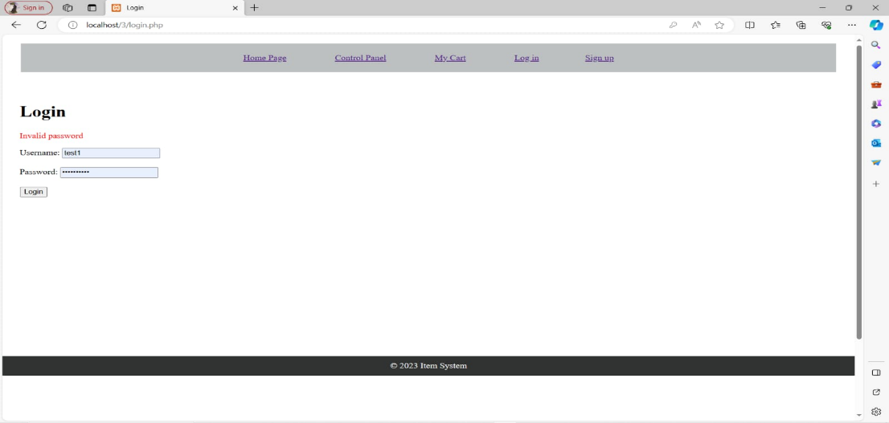

After signing up or log in:

After successful sign-up or login, the header adjusts dynamically. The "Sign In" option transforms into "Welcome" followed by the username (e.g., "Welcome Rail"). Simultaneously, the "Sign Up" option changes to "Log Out." This provides users with clear visual cues indicating their logged-in status and the availability of the log-out option.

This wraps up our website overview. We've strived to create a user-friendly and informative platform. All the details provided aim to assist users in navigating and utilizing our website effectively. Thank you for choosing our platform. If you have any further questions or need assistance, feel free to reach out. Happy browsing!